PITOPIA

[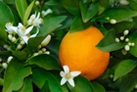](http://www.pitopia.de/scripts/pictures/detail.php?pid=98112&pageID=1&view=1)

[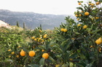](http://www.pitopia.de/scripts/pictures/detail.php?pid=446140&pageID=1&view=1)

[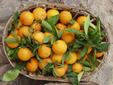](http://www.pitopia.de/scripts/pictures/detail.php?pid=559489&pageID=2&view=1)

[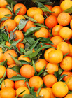](http://www.pitopia.de/scripts/pictures/detail.php?pid=963692&pageID=4&view=1)

[](http://www.pitopia.de/scripts/pictures/detail.php?pid=318547&pageID=5&view=1)

[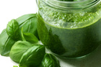](http://www.pitopia.de/scripts/pictures/detail.php?pid=320742&pageID=1&view=1)

[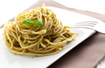](http://www.pitopia.de/scripts/pictures/detail.php?pid=925631&pageID=1&view=1)